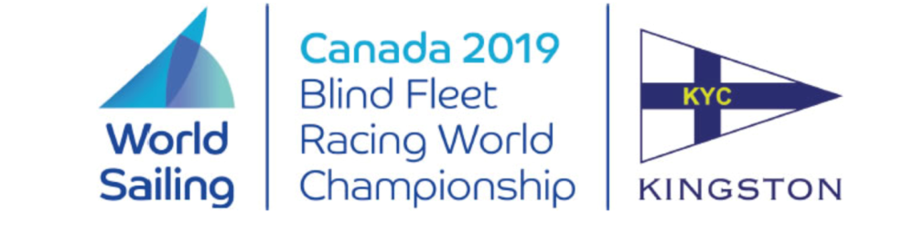

Notice to Competitors
Originally posted 2019-05-16
Corrected on 2019-05-29 to improve compatibility with screen readers

Amendment to Notice of Race #1

Delete all of 4.1 and replace with:

4.1 "The World Sailing Sailor Classification Code will not apply."

Massimo Dighe Rosemary Wilson
Technical Delegate Regatta Chair

