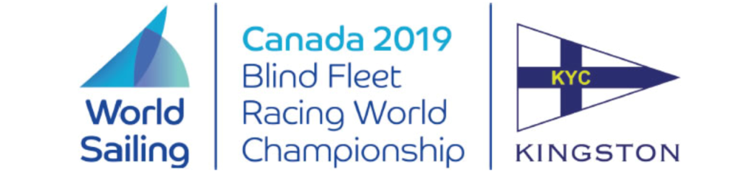

**Notice to Competitors**

Posted 2019-07-18

**Amendment to Notice of Race #2**

DELETE:

5.6. The use of any electronic navigational aids is not permitted.

INSERT:

5.6. The use of any electronic navigational aids is not permitted, other than compass, watches and VHF transceivers (from 4.2 of the Para World Sailing Race Management Manual).

Massimo Dighe Rosemary Wilson

Technical Delegate Regatta Chair