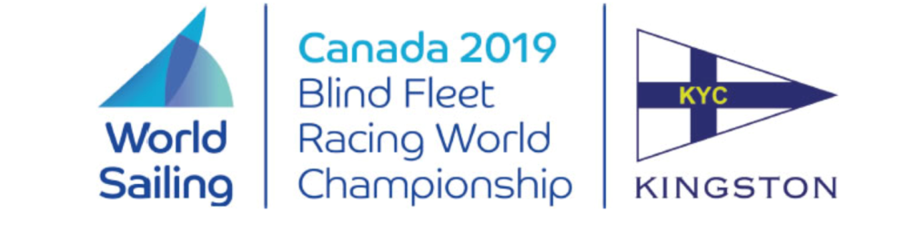

**Notice to Competitors**

Posted 2019-07-18

**Amendment to Notice of Race #3**

**ADD after 3.9.**

**"3.10. A recommendation to remove the eligibility criteria described Para World Sailing RMM above has been submitted to the World Sailing board. If this is subsequently passed, then NoR 3.10. will be deleted in an amended NoR and the eligibility criteria waived for the event."**

Massimo Dighe Rosemary Wilson

Technical Delegate Regatta Chair