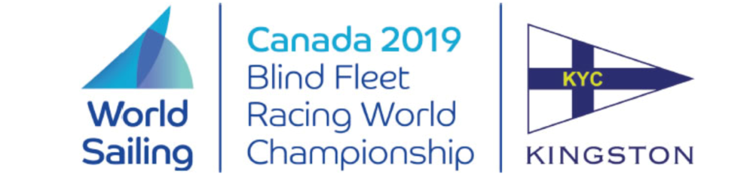

**Notice to Competitors**

Posted 2019-08-07

**Amendment to Notice of Race #4**

**ADD after 1.5.**

**"1.6. World Sailing and Sail Canada have approved a three person International Jury. Decisions of the international jury will be final as provided in RRS 70.5.”**

Massimo Dighe Rosemary Wilson

Technical Delegate Regatta Chair